# **Photon Server游戏服务器教程（一）服务器配置**

Photon Server 是一款实时的Socket服务器和开发框架，开发非常快速，使用非常简单。服务端架构在windows系统平台上，采用C#语言编写。Photon Server客户端SDK提供了多种平台的开发API，包括DotNet、Unity3D、C/C++以及ObjC等。这个Photon Server游戏服务器教程系列主要时帮助大家去理解和使用，下面就来看看Photon Server的配置。

**一、PhotonServer的下载与解压：**

1.PhotonServe的官方网站https://www.photonengine.com/zh-CN/Photon ，进入到官网后点击SDKs,选择Server 工程，点击SeverSDK ON-PREMISES进行下载，需要注册一个账号。

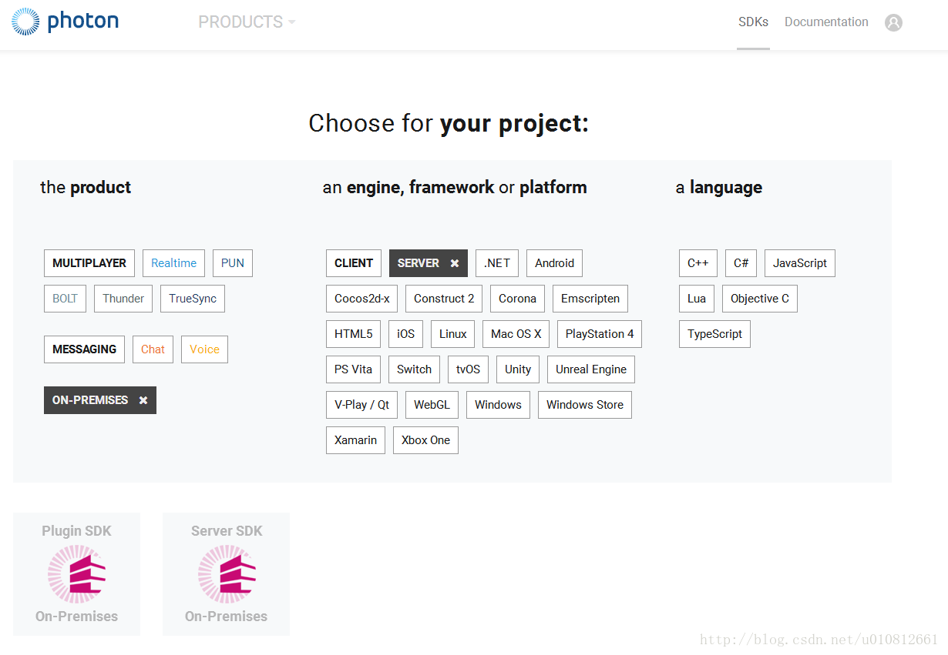

2.百度云盘，链接：：https://pan.baidu.com/s/1nvyyC21 密码：brn6

3.把下载的文件解压到指定的盘符即可（文件路径最好不要含有中文），无需安装，我这里解压在D:\Program Files (x86)文件目录下。

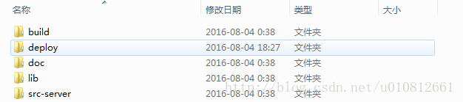

解压后得到5个文件夹

build：编译配置有关的文件。

deploy :主要存放photon的服务器控制程序和服务端Demo。

doc：存放PhotonServer开发的相关API文档。

lib:存放PhotonServer开发的相关动态链接库。

src-server:服务端Demo源代码

根据自己的电脑系统选择deploy文件夹下的bin_Win32或者bin_Win64文件下的PhotonControl.exe,点击运行Photon。

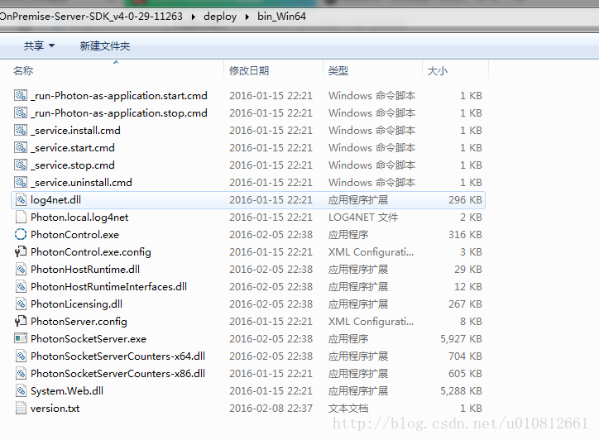

运行后会出现在右下角的托盘里

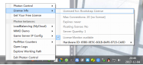

此时的Licenses 最大连接数量为20，如若想扩展到100，需在官网下载授权文件，放在deploy文件夹下的bin_Win32或者bin_Win64目录里面，下次运行时会自动识别授权文件。

选择 Your Server 选项

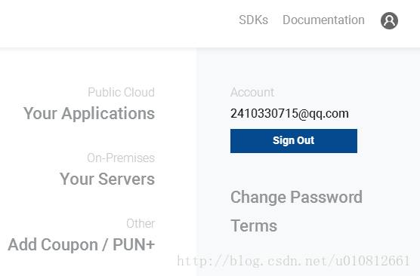

点击Download下载100 CCU文件即可。

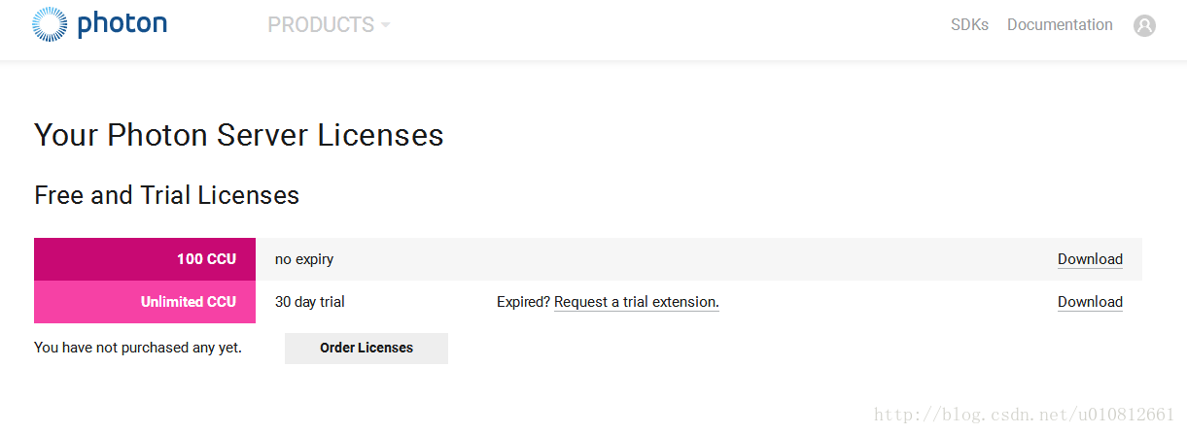

**二、搭建自己的服务器**

1.下面我们开始搭建自己的第一个Photon Sever 服务器端程序，在Visual Studio 2013中新建一个MyGamePhotonServer类库工程。

2.在工程中添加一下三个引用，文件在PhotonServer解压目录的lib文件夹中，三个dll分别是：ExitGamesLibs.dll，Photon.SocketServer.dll，PhotonHostRuntimeInterfaces.dll

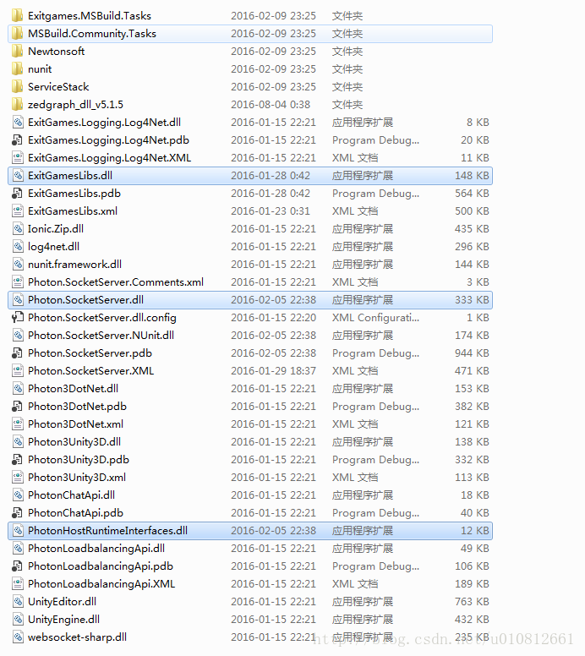

3.在此工程目录中添加入口类MyGameServer，继承ApplicationBase类，并实现其接口

using System;

using System.Collections.Generic;

using System.Linq;

using System.Text;

using System.Threading.Tasks;

using Photon.SocketServer;

namespace MyGamePhotonServer｛

/// 所有的server端 主类都要继承自ApplicationBase

public class MyGameServer:ApplicationBase ｛

/// 刚一个客户端请求连接的

protected override PeerBase CreatePeer(InitRequest initRequest) ｛

return new MyClientPeer(initRequest);

｝

/// 初始化

protected override void Setup() ｛｝

/// server端关闭的时候

protected override void TearDown() ｛｝

｝

｝

4.添加与客户端通信的类MyClientPeer， 需要继承ClientPeer类，并实现接口

using System;

using System.Collections.Generic;

using System.Linq;

using System.Text;

using System.Threading.Tasks;

using Photon.SocketServer;

namespace MyGamePhotonServer｛

public class MyClientPeer:ClientPeer｛

public MyClientPeer(InitRequest initRequest):base(initRequest)｛ ｝

/// 处理客户端断开连接后的操作

protected override void OnDisconnect(PhotonHostRuntimeInterfaces.DisconnectReason reasonCode, string reasonDetail)｛｝

/// 处理客户端的请求

protected override void OnOperationRequest(OperationRequest operationRequest, SendParameters sendParameters)｛｝

｝

｝

5.在deploy文件夹下新建一个MyGameServer\bin文件夹，在Visual Studio 2013中把我们刚创建的服务器程序MyPhotonServer部署在PhotonServer 中。

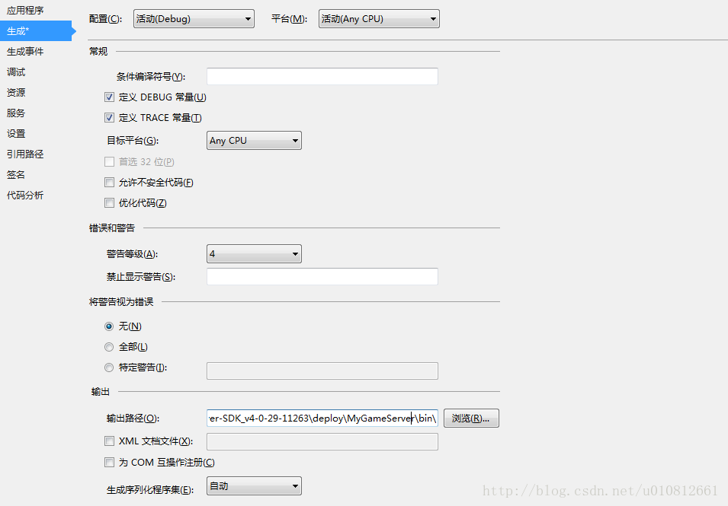

6.配置服务器：打开bin_Win64（如果你是32的就打开bin_Win32）文件夹下的PhotonServer.config，在Application标签下添加自己服务器配置文件。

&lt;Application

Name="MyGame"

BaseDirectory="MyGameServer"

Assembly="MyGamePhotonServer"

Type="MyGamePhotonServer.MyGameServer"

ForceAutoRestart="true"

WatchFiles="dll;config"

ExcludeFiles="log4net.config"&gt;

&lt;/Application&gt;

Name：这个就是程序名称

BaseDirectory就是我们发布后在deploy文件加下的路径：

Assembly：就是我们的类库工程生成的那个dll文件

Type：我们入口类的名称（要带上命名空间）

以下是完整的配置文件

&lt;?xml version="1.0" encoding="Windows-1252"?&gt;

&lt;!--

(c) 2015 by Exit Games GmbH, http://www.exitgames.com

Photon server configuration file.

For details see the photon-config.pdf.

This file contains two configurations:

"LoadBalancing"

Loadbalanced setup for local development: A Master-server and a game-server.

Starts the apps: Game, Master, CounterPublisher

Listens: udp-port 5055, tcp-port: 4530, 843 and 943

--&gt;

&lt;Configuration&gt;

&lt;!-- Multiple instances are supported. Each instance has its own node in the config file. --&gt;

&lt;LoadBalancing

MaxMessageSize="512000"

MaxQueuedDataPerPeer="512000"

PerPeerMaxReliableDataInTransit="51200"

PerPeerTransmitRateLimitKBSec="256"

PerPeerTransmitRatePeriodMilliseconds="200"

MinimumTimeout="5000"

MaximumTimeout="30000"

DisplayName="LoadBalancing (MyCloud)"&gt;

&lt;!-- 0.0.0.0 opens listeners on all available IPs. Machines with multiple IPs should define the correct one here. --&gt;

&lt;!-- Port 5055 is Photon's default for UDP connections. --&gt;

&lt;UDPListeners&gt;

&lt;UDPListener

IPAddress="0.0.0.0"

Port="5055"

OverrideApplication="Master"&gt;

&lt;/UDPListener&gt;

&lt;UDPListener

IPAddress="0.0.0.0"

Port="5056"

OverrideApplication="Game"&gt;

&lt;/UDPListener&gt;

&lt;/UDPListeners&gt;

&lt;!-- 0.0.0.0 opens listeners on all available IPs. Machines with multiple IPs should define the correct one here. --&gt;

&lt;TCPListeners&gt;

&lt;!-- TCP listener for Game clients on Master application --&gt;

&lt;TCPListener

IPAddress="0.0.0.0"

Port="4530"

OverrideApplication="Master"

PolicyFile="Policy\assets\socket-policy.xml"

InactivityTimeout="10000"

&gt;

&lt;/TCPListener&gt;

&lt;TCPListener

IPAddress="0.0.0.0"

Port="4531"

OverrideApplication="Game"

PolicyFile="Policy\assets\socket-policy.xml"

InactivityTimeout="10000"&gt;

&lt;/TCPListener&gt;

&lt;!-- DON'T EDIT THIS. TCP listener for GameServers on Master application --&gt;

&lt;TCPListener

IPAddress="0.0.0.0"

Port="4520"&gt;

&lt;/TCPListener&gt;

&lt;/TCPListeners&gt;

&lt;!-- Policy request listener for Unity and Flash (port 843) and Silverlight (port 943) --&gt;

&lt;PolicyFileListeners&gt;

&lt;!-- multiple Listeners allowed for different ports --&gt;

&lt;PolicyFileListener

IPAddress="0.0.0.0"

Port="843"

PolicyFile="Policy\assets\socket-policy.xml"&gt;

&lt;/PolicyFileListener&gt;

&lt;PolicyFileListener

IPAddress="0.0.0.0"

Port="943"

PolicyFile="Policy\assets\socket-policy-silverlight.xml"&gt;

&lt;/PolicyFileListener&gt;

&lt;/PolicyFileListeners&gt;

&lt;!-- WebSocket (and Flash-Fallback) compatible listener --&gt;

&lt;WebSocketListeners&gt;

&lt;WebSocketListener

IPAddress="0.0.0.0"

Port="9090"

DisableNagle="true"

InactivityTimeout="10000"

OverrideApplication="Master"&gt;

&lt;/WebSocketListener&gt;

&lt;WebSocketListener

IPAddress="0.0.0.0"

Port="9091"

DisableNagle="true"

InactivityTimeout="10000"

OverrideApplication="Game"&gt;

&lt;/WebSocketListener&gt;

&lt;/WebSocketListeners&gt;

&lt;!-- Defines the Photon Runtime Assembly to use. --&gt;

&lt;Runtime

Assembly="PhotonHostRuntime, Culture=neutral"

Type="PhotonHostRuntime.PhotonDomainManager"

UnhandledExceptionPolicy="Ignore"&gt;

&lt;/Runtime&gt;

&lt;!-- Defines which applications are loaded on start and which of them is used by default. Make sure the default application is defined. --&gt;

&lt;!-- Application-folders must be located in the same folder as the bin_win32 folders. The BaseDirectory must include a "bin" folder. --&gt;

&lt;Applications Default="Master"&gt;

&lt;Application

Name="Master"

BaseDirectory="LoadBalancing\Master"

Assembly="Photon.LoadBalancing"

Type="Photon.LoadBalancing.MasterServer.MasterApplication"

ForceAutoRestart="true"

WatchFiles="dll;config"

ExcludeFiles="log4net.config"

&gt;

&lt;/Application&gt;

&lt;Application

Name="Game"

BaseDirectory="LoadBalancing\GameServer"

Assembly="Photon.LoadBalancing"

Type="Photon.LoadBalancing.GameServer.GameApplication"

ForceAutoRestart="true"

WatchFiles="dll;config"

ExcludeFiles="log4net.config"&gt;

&lt;/Application&gt;

&lt;!-- CounterPublisher Application --&gt;

&lt;Application

Name="CounterPublisher"

BaseDirectory="CounterPublisher"

Assembly="CounterPublisher"

Type="Photon.CounterPublisher.Application"

ForceAutoRestart="true"

WatchFiles="dll;config"

ExcludeFiles="log4net.config"&gt;

&lt;/Application&gt;

&lt;/Applications&gt;

&lt;/LoadBalancing&gt;

&lt;!-- Instance settings --&gt;

&lt;MyGameInstance

MaxMessageSize="512000"

MaxQueuedDataPerPeer="512000"

PerPeerMaxReliableDataInTransit="51200"

PerPeerTransmitRateLimitKBSec="256"

PerPeerTransmitRatePeriodMilliseconds="200"

MinimumTimeout="5000"

MaximumTimeout="30000"

DisplayName="MyGameDemo"

&gt;

&lt;!-- 0.0.0.0 opens listeners on all available IPs. Machines with multiple IPs should define the correct one here. --&gt;

&lt;!-- Port 5055 is Photon's default for UDP connections. --&gt;

&lt;UDPListeners&gt;

&lt;UDPListener

IPAddress="0.0.0.0"

Port="5055"

OverrideApplication="MyGame"&gt;

&lt;/UDPListener&gt;

&lt;/UDPListeners&gt;

&lt;!-- 0.0.0.0 opens listeners on all available IPs. Machines with multiple IPs should define the correct one here. --&gt;

&lt;!-- Port 4530 is Photon's default for TCP connecttions. --&gt;

&lt;!-- A Policy application is defined in case that policy requests are sent to this listener (known bug of some some flash clients) --&gt;

&lt;TCPListeners&gt;

&lt;TCPListener

IPAddress="0.0.0.0"

Port="4530"

PolicyFile="Policy\assets\socket-policy.xml"

InactivityTimeout="10000"

OverrideApplication="MyGame"

&gt;

&lt;/TCPListener&gt;

&lt;/TCPListeners&gt;

&lt;!-- Defines the Photon Runtime Assembly to use. --&gt;

&lt;Runtime

Assembly="PhotonHostRuntime, Culture=neutral"

Type="PhotonHostRuntime.PhotonDomainManager"

UnhandledExceptionPolicy="Ignore"&gt;

&lt;/Runtime&gt;

&lt;!-- Defines which applications are loaded on start and which of them is used by default. Make sure the default application is defined. --&gt;

&lt;!-- Application-folders must be located in the same folder as the bin_win32 folders. The BaseDirectory must include a "bin" folder. --&gt;

&lt;Applications Default="MyGame"&gt;

&lt;!-- MyGame Application --&gt;

&lt;Application

Name="MyGame"

BaseDirectory="MyGameServer"

Assembly="MyGamePhotonServer"

Type="MyGamePhotonServer.MyGameServer"

ForceAutoRestart="true"

WatchFiles="dll;config"

ExcludeFiles="log4net.config"&gt;

&lt;/Application&gt;

&lt;/Applications&gt;

&lt;/MyGameInstance&gt;

&lt;/Configuration&gt;

7.启动服务器程序 MyGameDemo

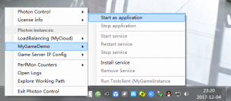

到此为止我们的第一个Photon Server 服务器就搭建好了。

来自：https://blog.csdn.net/u010812661/article/details/78710548